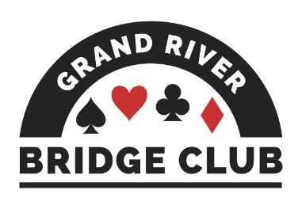PLAY AND LEARN BRIDGE IN A WELCOMING ENVIRONMENT245

ALERT – April 17, 2023

Click here to access our regular game schedule.

Looking Ahead

 Our two Friday games (April 14) will be upgraded club championships – extra masterpoints, no extra cost.
 Both of our weekend virtual games (April 15 and 16) will be ACBL Charity Foundation Games. Double black points, $7BBO
 The Friday night game on April 21 has been cancelled because so many of the regulars will be in Gatlinburg.
 All of our virtual games during the week of April 24-30 will be Silver Linings Games, 150% silver points, $7BBO.
 The Tuesday, April 25 open F2F game will be an ACBL/CBF charity game while the Friday, April 28 499er F2F game will be a local charity game, the proceeds of which will go to the Waterloo Food Bank.
 Barbara Seagram will be at our club on Wednesday, May 3. Click here for more in formation and to register. Number of spots remaining: 35.
--------------------------------------------------------------------------------------------------------------------------------------------
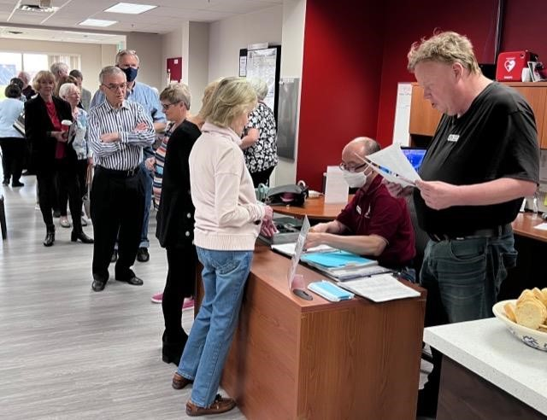 We Turned 11!

A good time was had by all last Tuesday when our club celebrated its eleventh birthday with a rookie/master game. We were pleased to get a turnout of 58 players, many of whom were assigned partners they either knew only slightly or else had never met before. It was a terrific way to make new friends and get to know each other better. Mike and Al did a great job of organizing and directing the game.
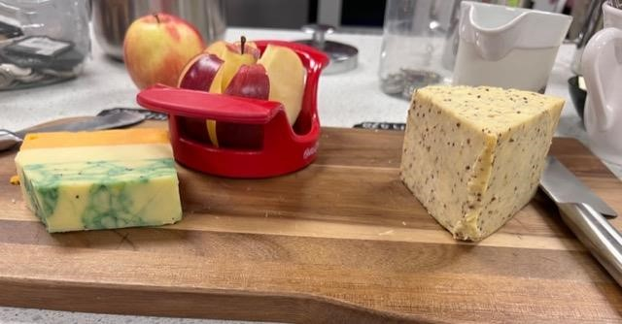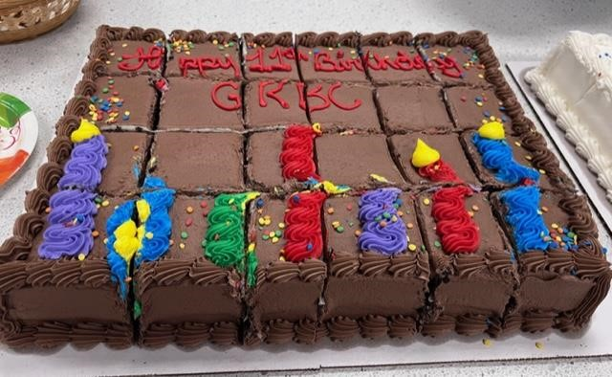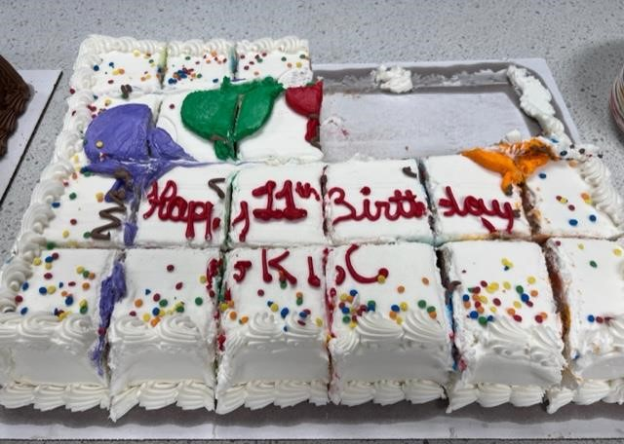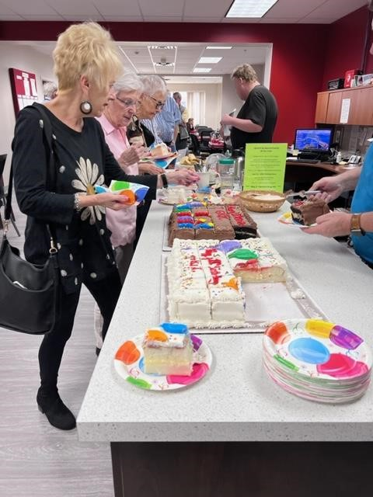

There were wonderful treats, including not one but two birthday cakes.

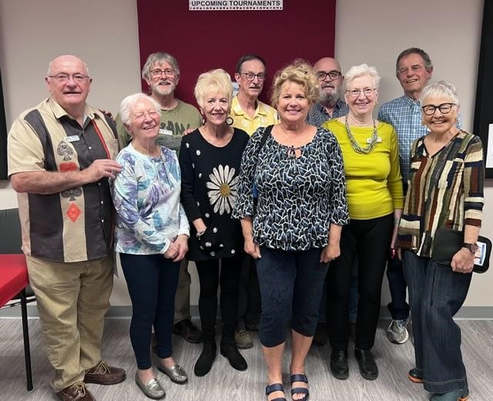
Here is a group photo of most of the top three winners, one from each section. From left to right: Dave Quarrie, Audrey Cook, Steve Allen, Cindy Mahn, Rick Arthur, Sharon Nesbitt, Dave Baker, Joan Slover, Bob Griffiths, and Sharon Boyd. Missing are Diane Jamieson and Barbara Arthur.

The Bean Counter
Contributed by Steve Allen, Treasurer
Over the pa$t month, I have been focu$ed on finance$ in the pa$t. It doe$n’t mean that I long for the Covid day$. Thi$ week … let’$ eyeball current revenue$ and expen$e$. In a typical month, we spend ~$10,000 (REALLY!) as follows:
- Dare Foods rent is $5,400. It’s a fixed amount that will stay that way until July when it will go up by a puny 2%. When one factors in what’s included in the lease (heating, air conditioning, water, electricity, property taxes, property maintenance (for example, snow shoveling), it is not that large.
- The certified directors who run our BBO and F2F games don’t tolerate your demanding calls of “Director!” for free. The amount will vary each month but it is ~$3,200 on average.
- ACBL dings us for ~$900 to pay for BBO’s costs and BBO/F2F table costs
- Everything else amounts to ~$500 (eg. cleaning, bathroom/kitchen supplies, office supplies, banking fees)
From time to time, we experience a significant expense like a new refrigerator or a quarterly
~$1,200 HST payment to the good ol’ CRA.
This information raises the obvious question: how do we pay for this? Monthly income pours in from one main source: Your wallet! You pay ~$10,000 every month for memberships, BBO/F2F games, lessons, labs, books and name tags. And it’s all variable (or in accounting terms, frickin’ unpredictable).
Did you do the math? Typical monthly income equals typical monthly expenses. As a result, the GRBC treads water every month, wondering if we will drown (lose money) or float (make money). We experience both.…
--------------------------------------------------------------------------------------------------------------------------------

TIme You Learned our Lessons!

NOT IN THE CARDS (GET IT?)
We have had to cancel or postpone the following workshops due to low enrollment.
- Opening Leads
- Mini-Splinters and Splinters
- Negative Free Bids
We apologize for any inconvenience.
----------------------------------------------

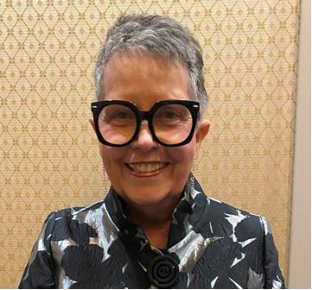 Tricks Out of Nowhere
You are invited to a fun, informal bridge lecture, lunch, and play day hosted by acclaimed bridge author, teacher, and goodwill ambassador Barbara Seagram. All are welcome to join us for Barbara's "Tricks Out of Nowhere" workshop, followed by lunch and an afternoon game. The afternoon game will be a 499er club championship game (extra masterpoints) with three strats (so that even beginners will have a chance at those extra points), and Barbara will be playing - meaning that some participants will get to play against her!
Pre-registration with payment is required by April 26. Attendance is limited to 78. Barbara's workshops always sell out, so book early to avoid disappointment.
In order to register, you need to take TWO actions: REGISTER for the workshop/lunch/game and ARRANGE FOR PAYMENT (information on paying will be provided on the registration confirmation page).
Instructor: Barbara Seagram
Date: Wednesday, May 3, 9:30 am – 4:30 pm
Level: Novice/Intermediate
Cost: $35 (HST included) NO REFUNDS
Venue: In person at our club
Current Enrollment: 45
Click here for more information and to register.
--------------------------------------------------------------------------------------------------------------------------------------------

The Dullest Hand of the Match
Contributed by Robert Griffiths
We were playing a small (six-board) Swiss match at the Toronto tournament. Sometimes a small match can swing on any of the six hands, usually a slam or game bid and made at one table and not at the other.
Lots had gone on at our table. The opponents had bid and made a tough slam, and there were close games by both sides that could have been swings.

Board 12  South Deals  E-W Vul | ♠ A Q 8 4 3  ♥ Q 7  ♦ K 7 3
 | ♣ J 3 2
N
W | E
S
♣ |  | ♣
♠ K 7 6
♥ 10 8 3
♦ A 9 8
♣ 10 9 5 4
West | North East | South
 |  | Pass
Pass | 1♠ Pass | 2
3♣ | All Pass
♠ 10 2 ♠ J 9 5
♥ A J 9 ♥ K 6 5 4 2
♦ Q 6 2 ♦ J 10 5 4 A K Q 7 6 8

Then came this little hand. North dealt and opened 1, East passed. I was South and found a simple raise to 2. West was afraid that his opponents were attempting to steal the hand and came in with 3♣. Non-vulnerable players have been known to open the bidding and raise with very little.

North passed, having nothing more to say. East was unhappy, but with a bad hand it is not sensible to go searching for a suit at the three level. With my horrible shape and minimum raise, I wasn't going to bid again, so West bought the contract for 3♣.

We won our two spades, two diamonds and one club = down one, +100 for N/S. On to the next board.

At the other table, North also opened 1. They were playing constructive single raises, meaning that if South bid 2, he would be promising more than a flat hand with second HCP. So, South bid 1NT (forcing), planning to bid 2 the next time around.

This gave West a chance to bid 2♣ and get his club bid in at a level lower than the West player at our table. 2♣ was passed back to South who now bid 2, showing his weak raise.

This time West had no reason to feel that his side hadn't been heard. He passed 2, knowing that his partner still might back into the auction. Not this time: 2 was passed out.

East led his singleton club and West won three clubs and then led a fourth. North did his best by throwing a losing heart on the fourth club as East ruffed, but North was doomed to lose two red tricks. The contract went down one, +50 for EW.

That 150-point difference gave us a four-IMP gain on the hand. We were surprised to find that the other five boards in the match were even, so this board made all the difference. At both tables, the board was seen as a “nothing” board squeezed in between the ones that mattered.

A traditional single raise promises six-nine HCP in support of partner's major opening. But in the more modern two over one, a constructive raise promises more: a good seven to a poor ten points. There is a pre-emptive value to the 1-2 sequence that was missed by the pair whose system forced them to bid 1NT before showing spade support.

 Every bidding convention has its strengths and weaknesses.
--------------------------------------------------------------------------------------------------------------------------------------------

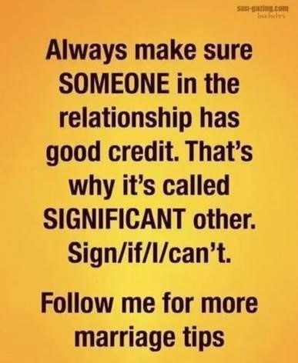

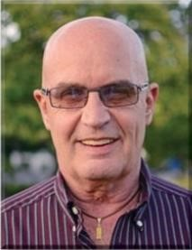 Dear David

Lead-Directing Penalty Doubles

In auctions where you and your partner have passed throughout, a (surprise!) double is for penalty and asks partner to lead dummy’s first-bid suit. You would normally use this agreement more frequently in team games, because your objective at teams is to defeat their game bids at all costs. If your lead-directing double doesn’t work out the way you had hoped, you will suffer a small loss at teams, but if it fails at matchpoints you will get a bottom instead of the average score you were headed for had you not doubled.

So, I am playing at the club, increasingly anxious because I am not getting many chances to contribute some good results. Along comes board 18.

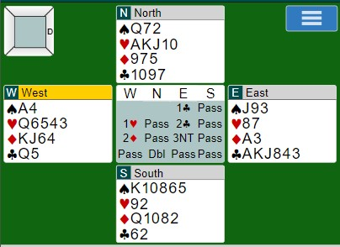

I thought that if partner could be induced to lead a heart and subsequently had an entry to lead a second heart, we might beat this a trick. Alas, no side entry was to be found. 3NT doubled plus two overtricks = -750 and zero matchpoints. Passing would have garnered an average. The number of people who came to me after to congratulate me on my brilliance was the same as my matchpoint score. I lost count of those who came to tease.

Today, we were having a reasonable game online. Then came another potentially disastrous board 18.

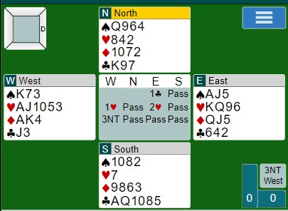

Once again, I could see the potential of defeating them if my partner could be induced to lead a club. If it turned out badly, we would get a bottom and ruin our chances of being in the money. As you can see, a club lead would lead to defeating 3NT by a trick. What I failed to appreciate was the fact that they had eschewed the normal heart contract for the potentially better-paying NT contract. Indeed, all the other tables made 11 tricks in hearts while they made 11 tricks in NT, so we got a bottom anyway. We ended up finishing second. If they had played in hearts or if I had doubled 3NT (which would probably induce West to run back to hearts), we would have finished first.

Tomorrow, a new game awaits.

--------------------------------------------------------------------------------------------------------------------------------------------
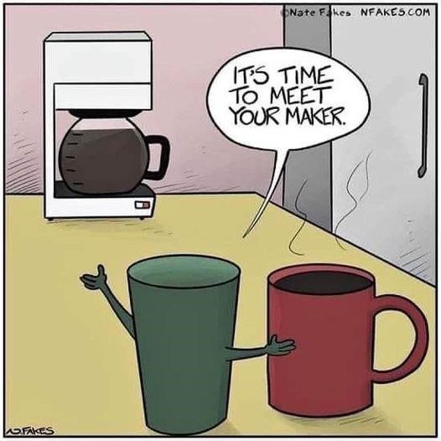
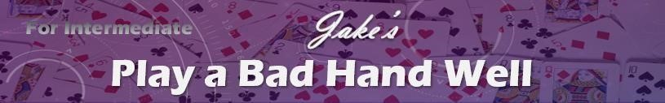

No. 110

♠ J63
♥ 10764 ♦ A9632
♣ 2Jake

♠ KQ9
♥ AQ3
♦ KJ#110
♣ AQ1073
West | North East | South
 | Pass 2♠ | 3NT
All pass

I was South declaring a 3NT contract. West led his partner’s suit, the ♠4. I played small from dummy, East played the ♠10, and I took the trick with my ♠Q. I then led my ♦K and everyone followed with a small diamond (East played the ♦7). I continued with my ♦J, which West covered with his ♦Q. If you were in my shoes, what would you do now?

SOLUTION

Your hand has two more tenaces (interrupted sequences of high cards of the same suit, such as the king and jack or the ace and queen). You would like to be able to finesse East twice (in hearts and clubs) because of your tenaces in these suits, but unfortunately your dummy doesn’t have a lot of entries. One way around this problem is to try to put your left-hand opponent (West) on lead as much as possible and force him to lead into your tenaces.

So, at Trick 3 you should let West win his ♦Q (it turns out that East started with a singleton diamond, he will discard a small heart). Now, West has limited options. He has no more spades (East promised six spades with his weak two bid), and West can see that leading a heart or a diamond would be just asking for trouble. His best option is to lead a small club.

You should take this club in your hand with the lowest possible card and then lead a small heart and see what happens. On this hand (as you will see if you peek at the actual deal at the bottom), West will be forced to win the trick*. [*As an aside, if East can win a heart trick, you’re still safe as you have another spade stopper. It’s only if East can win two heart tricks that your contract will fail - but it’s pretty unlikely that East would have two heart honours given his weak two opening bid.]

As it happens, today the bridge gods are kind and West is on lead at Trick 5. Life is good. West will probably lead another club, allowing you to pitch one of dummy’s diamonds. Now you continue the heart attack, cashing your ace and then leading the ♥Q. Once again, West has no good options, but let’s say he leads another club, leaving this four-card ending.

♠ J6
♥ 10
♦ A
♣ Jake
♠ #110 ♠ A875
♥ ♥
♦ 1085 ♦ Jake
♣ J ♣
♠ K9
♥
♦ #110 ♣ 73

By now, you have lost three tricks to the ♦Q, ♥J, and ♥K and can afford to lose one more trick. Now you get to execute one more endplay by leading the ♠K. If East takes the ♠K with his ♠A, he is endplayed in that he will have to lead a spade to dummy’s ♠J and let you cash dummy’s remaining good cards. If East refuses to take the ♠K, then you should switch to clubs and endplay West instead (you discard dummy’s last spade on this trick). West is forced to take his ♣J and lead a diamond to dummy’s ♦A and the good
♥10.

Here is the complete deal.

♠ J63
♥ 10764 ♦ A9632
♣ 2Jake
♠ 4#110 ♠ A108752
♥ KJ9 ♥ 852
♦ Q10854 ♦ 7Jake
♣ J865 ♣ K94
♠ KQ9
♥ AQ3
♦ KJ#110
♣ AQ1073

When you are short of dummy entries, consider forcing the opponents to help you out.
--------------------------------------------------------------------------------------------------------------------------------------------

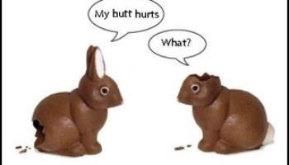

Top Master Point Earners at our Club Contributed by Allen Pengelly

This table lists the individuals who have earned the most master points at our club in each of three master point bands since the beginning of March.

 | Open Players |  |  |  | 499er Players |  |  |  | 99er Players
 | Name | MP |  |  | Name | MP |  |  | Name | MP
1 | David Baker | 25.00 |  | 1 | Lynda Burnett | 10.58 |  | 1 | Nancy Cattanach | 6.85
2 | Robert Griffiths | 21.21 |  | 2 | John Kip | 9.64 |  | 2 | Rick Arthur | 6.63
3 | Edith Ferber | 15.13 |  | 3 | Steve Allen | 9.30 |  | 3 | Louise Dawdy | 5.08
4 | Mike Peng | 12.68 |  | 4 | Lori Cole | 8.77 |  | 4 | Molly Worden | 4.16
5 | Kathy Russell | 11.86 |  | 5 | Cheryl Kip | 8.68 |  | 5 | Debbie Miethig | 3.95
6 | Colin Harrington | 11.21 |  | 6 | Barbara Arthur | 8.63 |  | 6 | Sharon Nesbitt | 3.70
7 | David Longstaff | 10.59 |  | 7 | Renate Boucher | 7.74 |  | 7 | Alicia Wright | 3.65
7 | Ted Boyd | 10.59 |  | 8 | Jim Dalgliesh | 7.72 |  | 8 | Kathy Chandler | 2.79
9 | Cindy Mahn | 8.48 |  | 9 | Cheryl White | 7.44 |  | 9 | Brian Gaber | 2.58
10 | Pat McMillan | 7.43 |  | 10 | Susan Durance | 7.40 |  | 10 | Elaine Doyle | 2.55
11 | Sharon Boyd | 7.23 |  | 11 | Roy Dandyk | 7.32 |  | 11 | Deborah Penrose | 2.45
12 | Dianne Aves | 6.64 |  | 12 | Shelley Metcalfe | 7.14 |  | 12 | MJ Hartleib | 2.28
13 | Scott Hills | 6.25 |  | 13 | David Dennis | 7.11 |  | 13 | Denise Dolff | 2.07
14 | Dave Quarrie | 6.23 |  | 14 | Martin Jones | 6.82 |  | 13 | Larry Brooks | 2.07
15 | Liz McDowell | 5.99 |  | 15 | Marlene Dopko | 6.80 |  | 15 | Sandra Kendall | 1.94
16 | John Hanemaayer | 5.43 |  | 16 | Jack Cole | 6.67 |  | 16 | Valirie Binkle | 1.81
17 | David Wilson | 5.36 |  | 17 | Robert Giilck | 6.05 |  | 16 | Pat Pietrek | 1.81
18 | Moira Hollingsworth | 5.12 |  | 18 | Andy Martinek | 6.01 |  | 18 | Judy Johnston | 1.74
19 | Sandy Graham | 4.74 |  | 19 | Nanci Phelan | 5.30 |  | 19 | Judy Charbonneau | 1.67
20 | Neil Jeffrey | 4.56 |  | 20 | Bob Livermore | 4.77 |  | 20 | Stu Cowan | 1.66
21 | Malkin Howes | 4.42 |  | 21 | Joe Blake | 4.61 |  | 21 | Don Slowinski | 1.53
22 | Frank Fischer | 3.91 |  | 22 | Suzanne Edwards | 4.53 |  | 21 | Ben Cornell | 1.53
23 | Ronna Hoy | 3.70 |  | 23 | Virginia Alviano | 4.37 |  | 23 | John Aldridge | 1.32
23 | Ed Hills | 3.52 |  | 24 | Brenda Semple | 4.23 |  | 24 | Belinda Burt | 1.31
25 | William Christian | 3.36 |  | 25 | Judy Beauchamp | 4.12 |  | 25 | Jane Wilson | 1.25

If you would like to play in a particular game but lack a partner that day, you can either:
- For both online and f2f games, log on to Pianola, click on Partner Finder, and create a Partner Finder advert. This needs to be done at least a few hours in advance of the game.
- For online games only, log in to the game in question and register yourself on the Partnership Desk tab.
If you are looking for a regular partner, contact Joan Slover, our membership lead.

We have fun in spades.
We play with all our hearts.
We treat our members like diamonds.
We enjoyed our rookie/master game at our club.

